Name: _____________________________ Date: ___________
Composition of Transformations
- The point is rotated 90º about the origin and then dilated by a scale factor of 4. What are the coordinates of the resulting image?

- What is the image of point (2, -3) under ?

3. Find the image of point under the composition of translations .

- The vertices of are , , and . The image of after the composition is . State the coordinates of . [The use of the set of axes below is optional.]
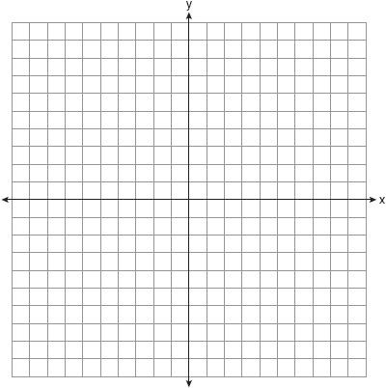

- Triangle ABC has coordinates , , and .
a On the grid below, draw and label .
b Graph and state the coordinates of , the image of after the composition .
c Write a transformation equivalent to .

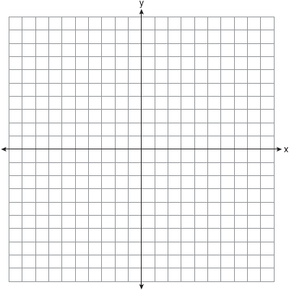
- On the accompanying grid, graph and label , where A is and B is . Under the transformation , A maps to , and B maps to . Graph and label . What single transformation would map to ?

- Given the transformations:
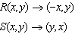
What is ?

- Given triangle TRY with vertices T(-2, 3), R(3, 6), Y(1, -1)
- Perform the composition of transformations $r$_{x-axis}R₉₀

b) State the single transformation equivalent to the above composition of transformations

- Given CAT with vertices C(-5, 3), A(2, 6), T(7, 1)
- Perform the composition of transformations R₉₀r_{y = x}

b) State the single transformation equivalent to the above composition of transformations

- Given DOG with vertices D(1, 2), O(5, 7), G(8, 4)
- Perform the composition of transformations r_{x-axis}r_{y =x}

- State the single transformation equivalent to the above composition of transformations

- As shown in the accompanying diagram, the star in position 1 on a computer screen transforms to the star in position 2.
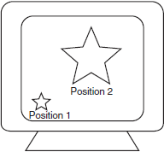
This transformation is best described as a
1) | line reflection
2) | translation
3) | rotation
4) | dilation

- After a composition of transformations, the coordinates , , and become , , and , as shown on the set of axes below.
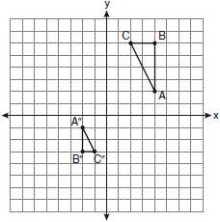
Which composition of transformations was used?
1)
2)
3)
4)
- On the accompanying grid, graph and label , where A is and B is . Under the transformation , A maps to , and B maps to . Graph and label . What single transformation would map to ?

14. The coordinates of the vertices of are , , and .
a On the graph below, draw and label .
b Graph and state the coordinates of , the image of after a reflection over the line .

c Graph and state the coordinates of , the image of after a reflection in the x-axis.

d Graph and state the coordinates of , the image of after the transformation .

